Lab Journal: 02

Date: 9/18/2025

Student : Lotfullah Muslimwal

Enrollment : 01-131232-039

Department of Software Engineering

Bahria University, Islamabad

Visual Programming-Lab (Fall-2025)

Teacher: Engr. RAHEELA AMBRIN

|  |  |  |  |  |  |
| --- | --- | --- | --- | --- | --- |
| **Task No:** | **Task Wise Marks** | | **Documentation Marks** | | **Total Marks**  **(20)** |
| **Assigned** | **Obtained** | **Assigned** | **Obtained** |
| 1 | 3 |  | 5 |  |  |
| 2 | 3 |  |
| 3 | 3 |  |
| 4 | 3 |  |
| 5 | 3 |  |

**Comments:**

**Signature**

# Lab No: 02 - Lab Title: Getting Started with C#

## Introduction

## In this lab, we explored the basics of programming in C# through console applications. The main focus was on understanding C# data types (Boolean, integral, floating-point, decimal, and string), as well as handling simple input and output with type conversion and formatting. Additionally, we studied and implemented control structures such as if, switch, while, do-while, and for loops. The exercises provided practical practice in using these concepts to perform tasks such as tax calculation, building a calculator, and generating number/character patterns.

## Tools Used

Visual Studio

## Task 2.1:

### Code for Task 2.1

### using System;

### class TaxCalculation

### {

### static void Main(string[] args)

### {

### Console.Write("\t\t\t ***** Excercise 2.1 ***** \n");

### Console.Write("\tEnter your income: ");

### double income = Convert.ToDouble(Console.ReadLine());

### double tax = 0;

### if (income < 10000)

### {

### tax = income * 0.05; // 5%

### }

### else if (income >= 10000 && income <= 100000)

### {

### tax = income * 0.08; // 8%

### }

### else

### {

### tax = income * 0.085; // 8.5%

### }

### Console.WriteLine($"\tYour income: {income:C}");

### Console.WriteLine($"\tCalculated Tax: {tax:C}");

### Console.ReadLine();

### }

### }

### Screenshot

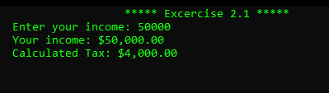

## Task 2.2:

### Code

### using System;

### class Calculator

### {

### static void Main(string[] args)

### {

### int choice;

### do

### {

### Console.WriteLine("\t***** Excercise 2.2 *****");

### Console.WriteLine("\n=== Simple Calculator ===");

### Console.WriteLine("1. Addition");

### Console.WriteLine("2. Subtraction");

### Console.WriteLine("3. Multiplication");

### Console.WriteLine("4. Division");

### Console.WriteLine("5. Exit");

### Console.Write("Enter your choice: ");

### choice = Convert.ToInt32(Console.ReadLine());

### if (choice >= 1 && choice <= 4)

### {

### Console.Write("Enter first number: ");

### double num1 = Convert.ToDouble(Console.ReadLine());

### Console.Write("Enter second number: ");

### double num2 = Convert.ToDouble(Console.ReadLine());

### switch (choice)

### {

### case 1:

### Console.WriteLine($"Result: {num1 + num2}");

### break;

### case 2:

### Console.WriteLine($"Result: {num1 - num2}");

### break;

### case 3:

### Console.WriteLine($"Result: {num1 * num2}");

### break;

### case 4:

### if (num2 != 0)

### Console.WriteLine($"Result: {num1 / num2}");

### else

### Console.WriteLine("Error! Division by zero.");

### break;

### }

### }

### } while (choice != 5);

### Console.WriteLine("Exiting Calculator. Goodbye!");

### }

### }

### Screenshot

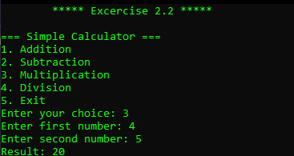

## Task 2.3:

## Code

### using System;

### class UpsideDownTriangle

### {

### static void Main(string[] args)

### {

### Console.Write("\t ******Excersice 2.3 ***** \n");

### Console.Write("Enter number of rows: ");

### int rows = Convert.ToInt32(Console.ReadLine());

### for (int i = rows; i >= 1; i--) // rows decreasing

### {

### // print leading spaces

### for (int space = rows - i; space > 0; space--)

### {

### Console.Write(" ");

### }

### // print stars

### for (int j = 1; j <= i; j++)

### {

### Console.Write("* ");

### }

### Console.WriteLine();

### }

### Console.ReadLine();

### }

### }

### Screenshot

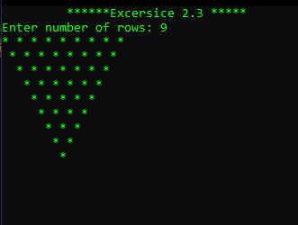

**Task 2.4:**

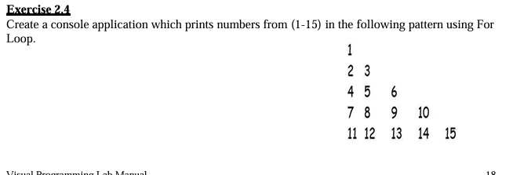

### Code

### using System;

### class NumberPattern

### {

### static void Main(string[] args)

### {

### Console.Write("\t *** Excersice 2.4 ***\n");

### int num = 1;

### for (int row = 1; row <= 5; row++) // 5 rows

### {

### for (int col = 1; col <= row; col++)

### {

### Console.Write(num + " ");

### num++;

### }

### Console.WriteLine();

### }

### Console.ReadLine();

### }

### }

### Screenshot

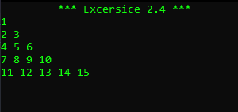

## Conclusion

This lab strengthened my understanding of C# fundamentals by combining data types, input/output handling, and control structures in real applications. I learned how to take user input, perform calculations, and display formatted output. Through exercises like tax calculation, a calculator app, and number patterns, I practiced writing structured programs using conditional statements and loops. Overall, this lab improved my problem-solving skills in C# and built a strong foundation for more advanced programming tasks.